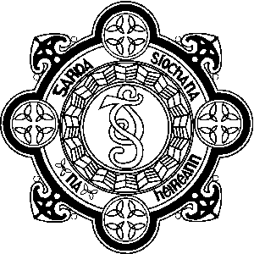

GARDA VETTING
PARENT/GUARDIAN CONSENT FORM

I, ___________________________________ (name)

of ___________________________________

___________________________________

___________________________________ (address)

being the ____________________
Father/Mother/Guardian

of ______________________________
Name of applicant for Garda Vetting

Date of birth of applicant: ____________________

do hereby consent for An Garda Síochána to conduct Garda Vetting in respect of the above named applicant and to furnish to the registered organisation for Garda Vetting, as indicated in the attached Garda Vetting application form, a statement that there are no convictions recorded against him/her in the Republic Of Ireland or elsewhere, or a statement of all convictions and/or prosecutions, successful or not, pending or completed, in the State or elsewhere as the case may be, subject to the administrative filter implemented by the Minister for Justice and Equality on 31st March 2014.

Signed: _____________________________
( )

Date: ____________________

Please attach this Parental/Guardian Consent form to your son’s/daughter’s application form

