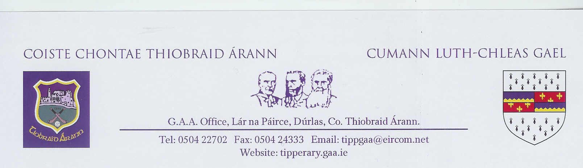
Level 1 Basic Foundation Club Referee Course 2020
Venue : Lár na Páirce, Thurles
Application Form

(Please complete the form using capital letters only)

Name: ____________________________________________________________________

Address: ____________________________________________________________________

Date of Birth: ____________________ Telephone No: ________________________________
Mobile No: ____________________ GAA Club: ________________________________

Email address: _______________________________ Membership No: __________________

Code requested: Hurling Football Both

(Please circle your choice)

Jersey Size S M L XL XXL Sock Size 4 - 7 7 - 11

Togs Size S M L XL XXL

(Please circle your size)

Both you and your club secretary are required to sign the application form. Payment of €100 by cheque is also required. Cheque made payable to Tipperary GAA Board. This fee will be returned to your club once you have refereed 10 games for your divisional or Co Board.

All referees must be Garda vetted before officiating.
All particulars / information relating to vetting applications can be accessed at https://www.gaa.ie/news/vetting/
(Note: All Garda vetting forms will be processed by the County Board Vetting Officer)

Signed (Applicant): ___________________________ Date: ____________________

Signed (Club secretary): ___________________________ Date: ____________________

Note: It is compulsory that all existing referees must complete an annual Fitness Assessment and Rules Test organised by the Co. Referees Committee together with an Annual In Service Training course, to be considered for officiating at games in all grades.

